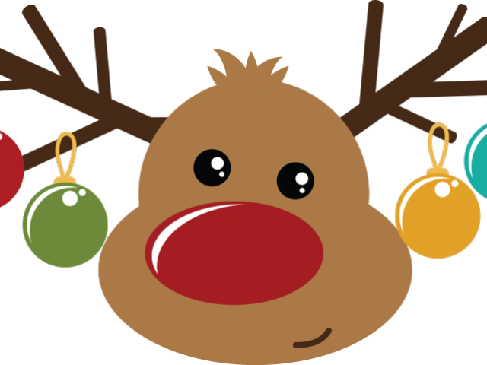

**December 23-January 3**- No School

**January 6-** return to School in 2020!

**January 13-** LEGO CLUB

**January 17-** End of 2nd Quarter/AR deadline for 2nd Quarter

Upcoming Events

Spelling Words

**\*Spelling Words attached \***

High Frequency Words:

(tested on reading these words)

any

from

happy

once

so

upon

December 20, 2019

Langemo News

**Library-** every Wednesday morning

**Art for our class:** December 16-20

January 6-10 and January 13-17

**\*Talk with your child about their classroom supplies- many are low in glue, crayons and dry erase markers\***

Classroom: