


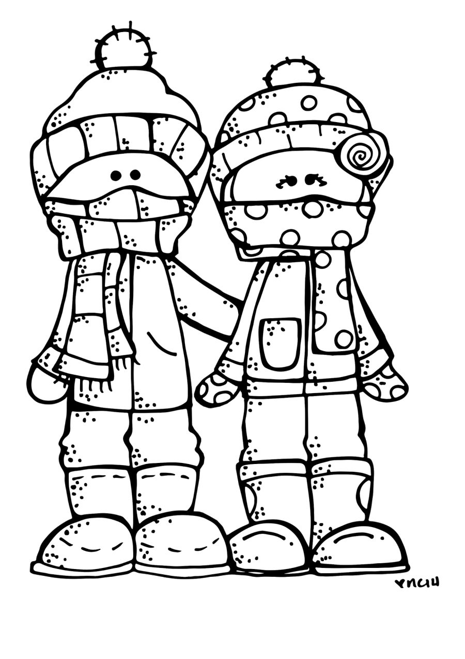

Langemo News
February 21, 2020

Spelling Words
*spelling words attached*

High Frequency Words:
(tested on reading these words)
caught
flew
know
laugh
listen
were

Library- every Wednesday morning

February 24- LEGO Club
March 4- WEAR ORANGE
March 9- LEGO Club
March 13- Family Movie Night – Arts and Events Center
March 23- LEGO club
March 25- Early Dismissal at 12:30

Classroom:
Upcoming Events

