


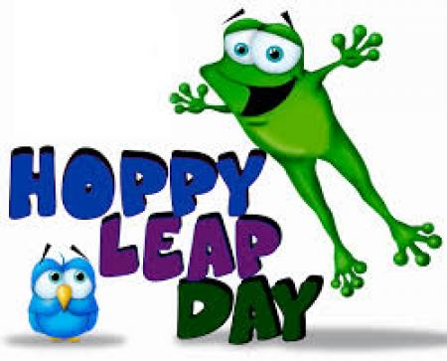

Langemo News
February 28, 2020

Spelling Words
*spelling words attached*

High Frequency Words:
(tested on reading these words)
found
hard
near
woman
would
write

Library- every Wednesday morning

March 2-6: Dr. Seuss Week – no orange day- dress up according to flyer
March 9- LEGO Club
March 13- Family Movie Night – Arts and Events Center 6:00
March 23- LEGO club
March 25- Early Dismissal at 12:30

Classroom:
Upcoming Events

